Walkthrough 22 Expression Binding

https://sapui5.hana.ondemand.com/#/topic/c98d57347ba444c6945f596584d2db45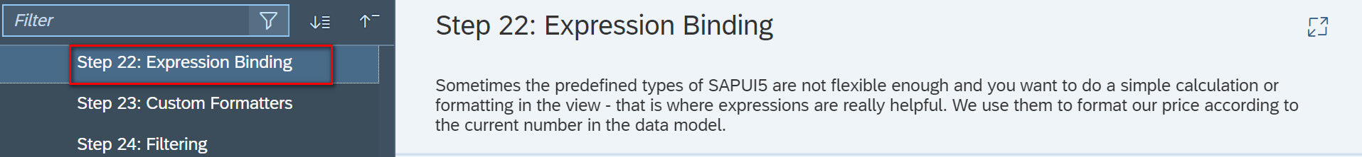

Core Changed Codes Compared to Last Version:

添加表达式绑定逻辑 InvoiceList.view.xml

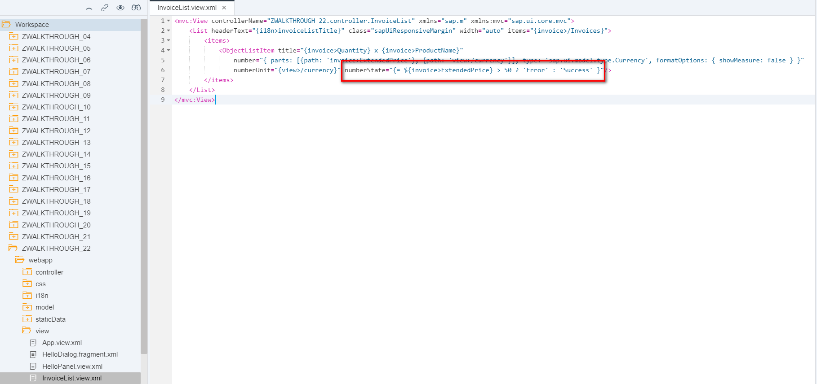

关于表达式绑定的其他详细用法,请参考以下链接

<https://sapui5.hana.ondemand.com/#/topic/daf6852a04b44d118963968a1239d2c0.html>

i18n 文本对象管理

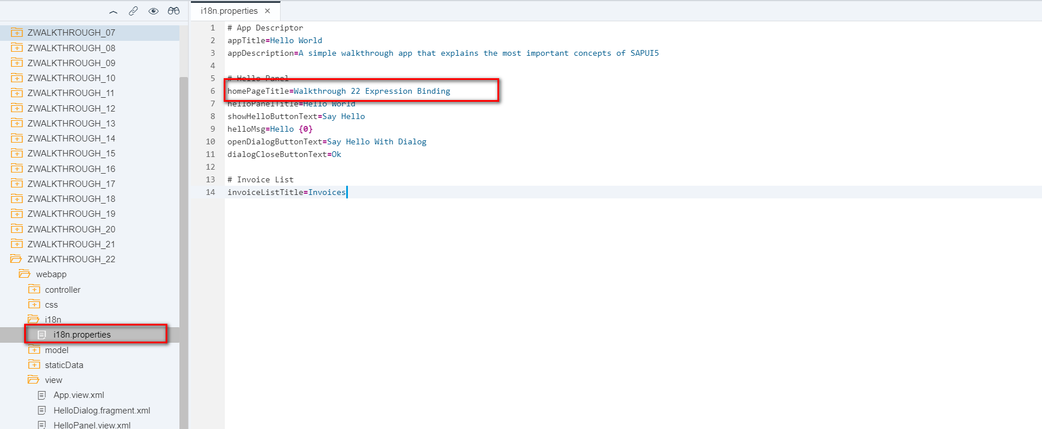

Result

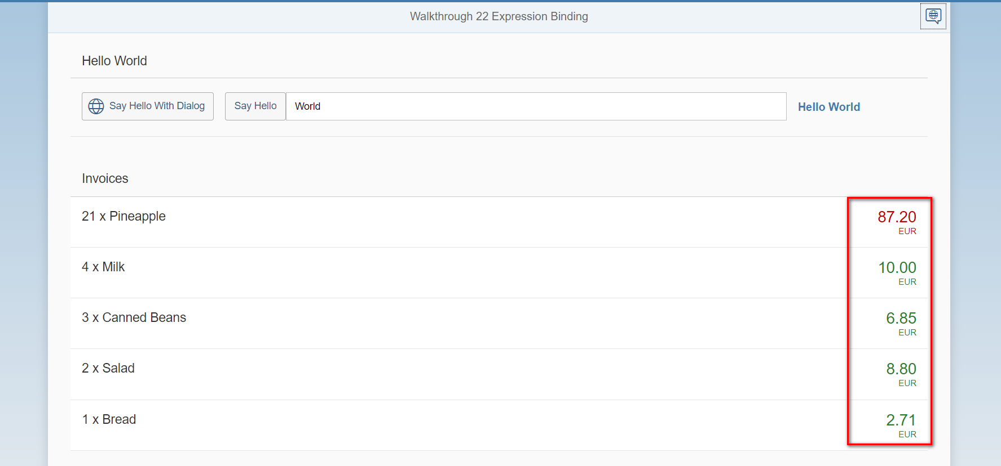

Git:

https://github.com/xiexiaop/SAPUI5-2-Round/tree/master/Projects/ZWALKTHROUGH_22

2019/02/01 XiaoMi Beijing Zac,Xie